﻿ 17/4/26

10.1 Transportation Problem (ships goods from sources to destinations)

E1 : Foster generations transporation problem
Transportation of a product (electric generator) from 3 plants to 4 distribution centers.

Problem data

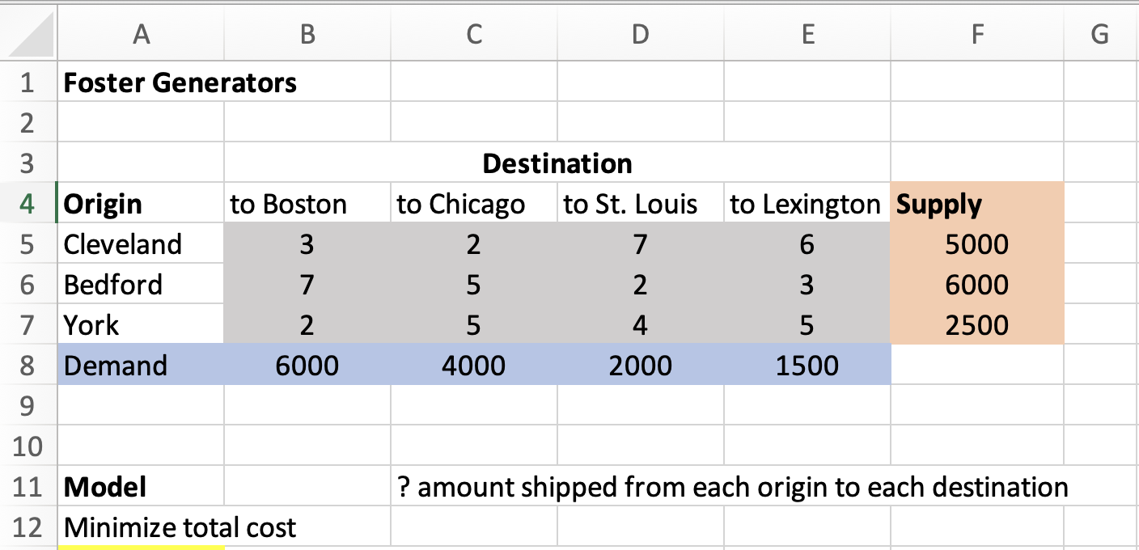

Network representation

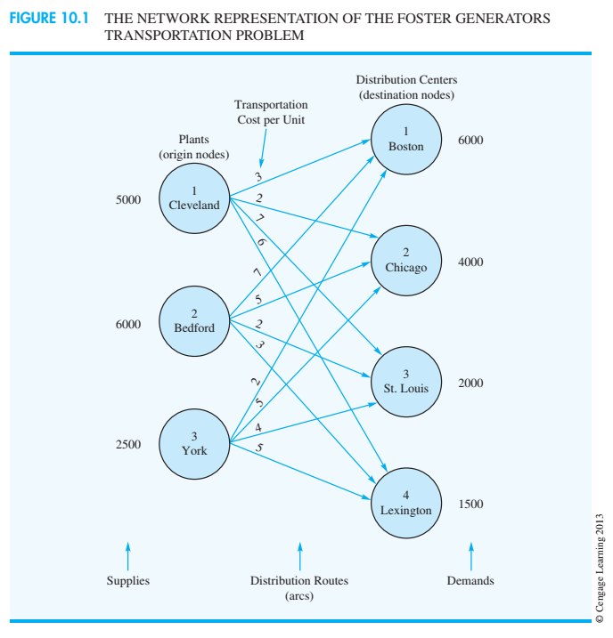

LP formulation

Decision vars | 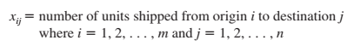
Objective | Minimize the total shipping cost  (from ﻿Cleveland)  + (from Bedford)  + (from York)
Constraints | Supply capacities : not exceeded  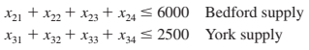  Meeting destination demands  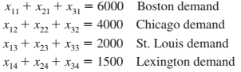  Non-negativity

Excel Solver / Simplex LP
Appendix 10.1 p474 - 476
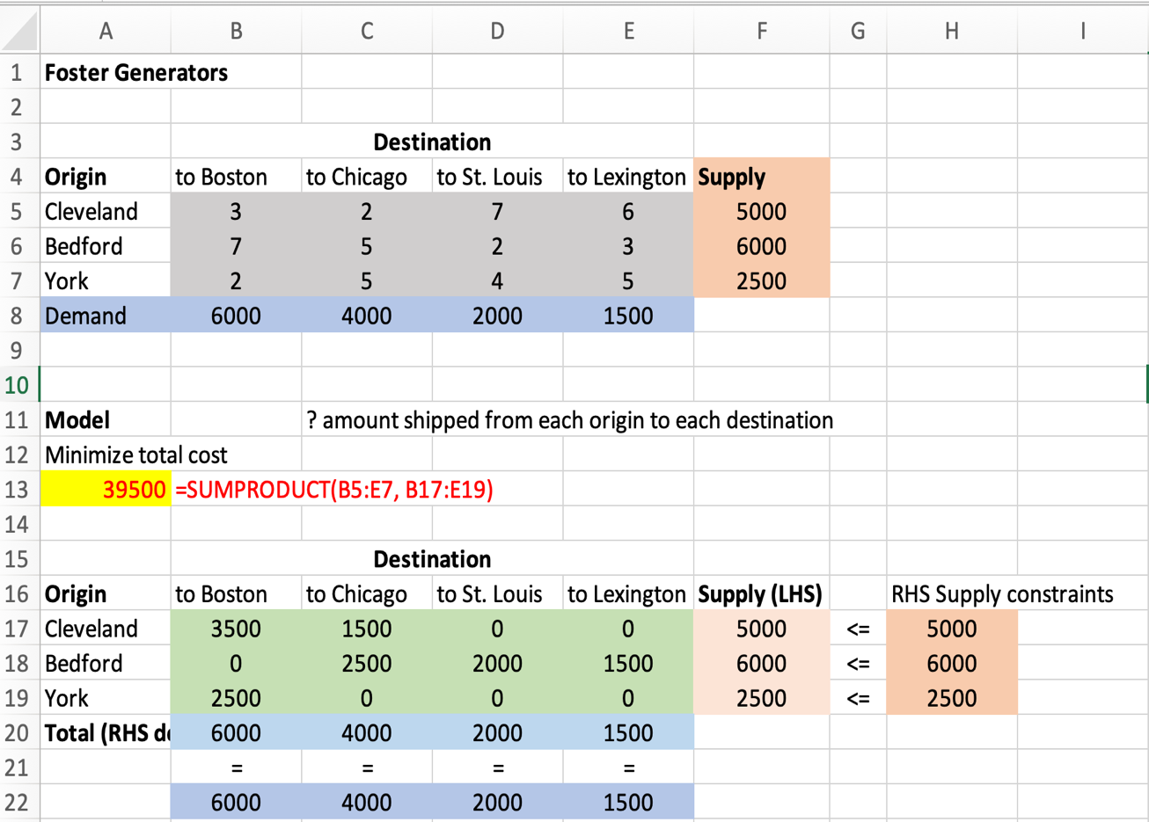

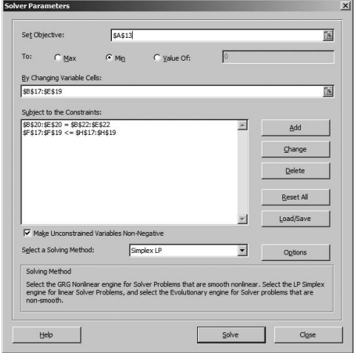

Optimal solns
﻿﻿
Network diagram for the optimal soln

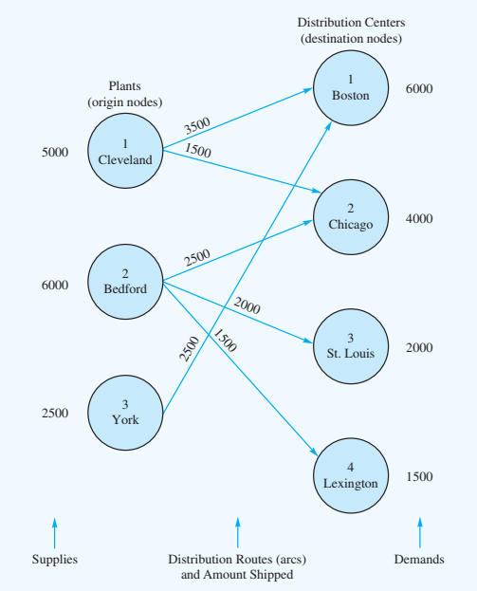

Practice probs

E1. P 453 (Network model)

E 2. p 453 (Excel solver)

E 6. p 455 (demand > supply, maximization obj)

10.1 Transshipment problem

﻿Ryan is an electronics company with production facilities in Denver and Atlanta. Components produced at either facility may be shipped to either of the firm’s regional warehouses, which are located in Kansas City and Louisville. From the regional warehouses, the firm supplies retail outlets in Detroit, Miami, Dallas, and New Orleans.

﻿Determine how many units should be shipped over each arc in the network so that all destination demands are satisfied with the minimum possible transportation cost.

Problem data
Transportation cost per unit for each distribution route
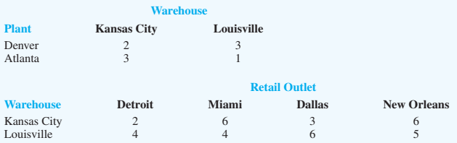

Network representation

Transportation cost per unit for each distribution route on arcs.

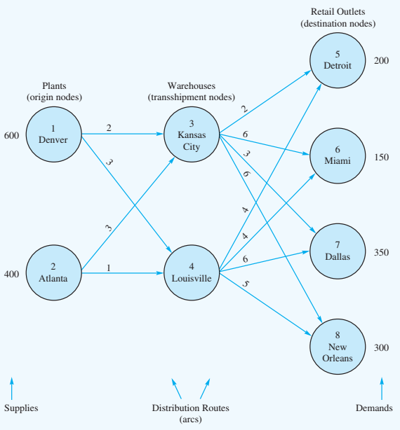

LP formulation
Decision vars | $x_{ij}$ = # units shipped from node $i$ to node $j$ (12 decision vars)  (the amount shipped over the arcs)
Objective | Minimize the total shipping cost  $$2⋅x_{13}+3x_{14}+3x_{23}+1⋅x_{24} \\ +2⋅x_{35}+6⋅x_{36}+3⋅x_{37}+6⋅x_{38} \\ +4⋅x_{45}+4⋅x_{46}+6x_{47}+5x_{48}$$
Constraints | Supply constraints (for each origin / plant)  $x_{13}+x_{14}≤600$(amount shipped from Denver)  $x_{23}+x_{24}≤400$(amount shipped from Atlanta)  Flow conservation constraints (@ each transshipment nodes)  (inflow = outflow @ warehouses)  $-x_{13}-x_{23}+x_{35}+x_{36}+x_{37}+x_{38}=0$ (@ Kansas)  $-x_{14}-x_{24}+x_{45}+x_{46}+x_{47}+x_{48}=0$ (@ Louisville)  Demand constraints (@ destination nodes)  (satisfy all destination demands / retail outlets)  $x_{35}+x_{45}=200$ (@ Detroit)  $x_{36}+x_{46}=150$ (@ Miami)  $x_{37}+x_{47}=350$ (@ Dallas)  $x_{38}+x_{48}=300$ (@ New Orleans)  Non-negativity $x_{ij}≥0$

Excel solver
Appendix 10.1 p476 - 478
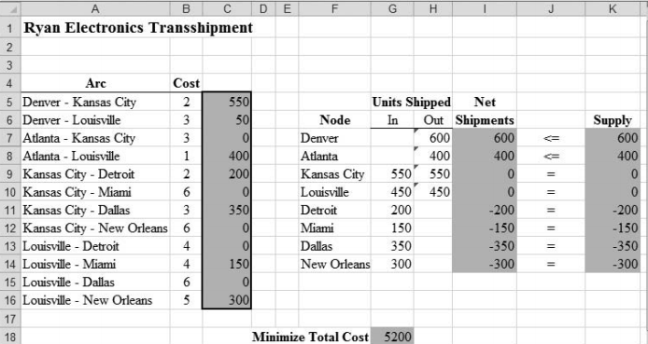

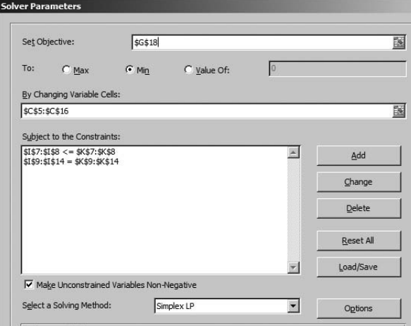

Optimal soln

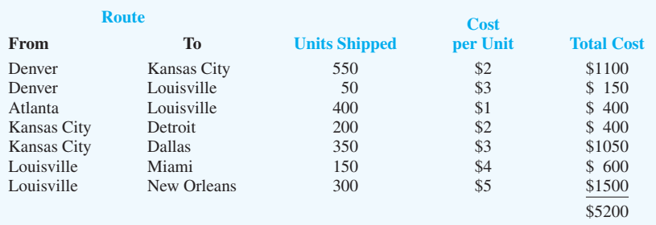

6. Practice probs

E11 a) (Network representation)

E11 b) (LP formulation)

E12 (general transshipment prob)

10.2 Assignment problem

Fowle marketing research assignment problem
(Project leader – client assignments)

One-to-one assignment:
- Each agent (project leader) gets exactly one task
- Each task (client) gets exactly one agent.

$⇒$ set of assignments -> optimize objective (minimize cost/ time or maximize profits)

1. Problem data
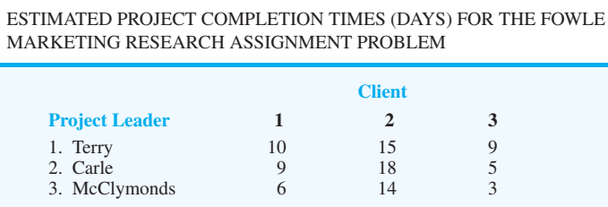

2. Network representation

Cost of assigning = the estimated completion time (days)
All supply & demand vals = 1
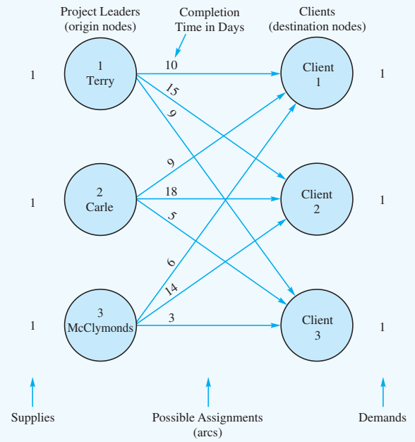

3. LP formulation

Decision vars | $x_{ij}=$1 or 0  (whether an agent $i$ is assigned to a task $j$)
Objective | Minimize the total shipping cos$t$  $10 x_{11}+ 15 x_{12}+9 x_{13}$(Terry’s)  $+ 9 x_{21}+18 x_{22}+5 x_{23}$ (Carle’s)  $+ 6 x_{31}+14 x_{32}+3 x_{33}$ (McClymond’s)
Constraints | Supply constraints (for each origin / plant)  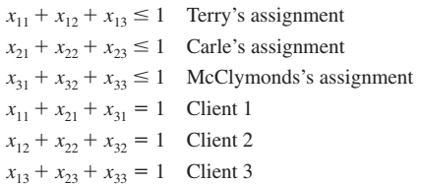  Non-negativity $x_{ij}≥0$

4. Excel solver
Appendix 10.1 p 478 – 480

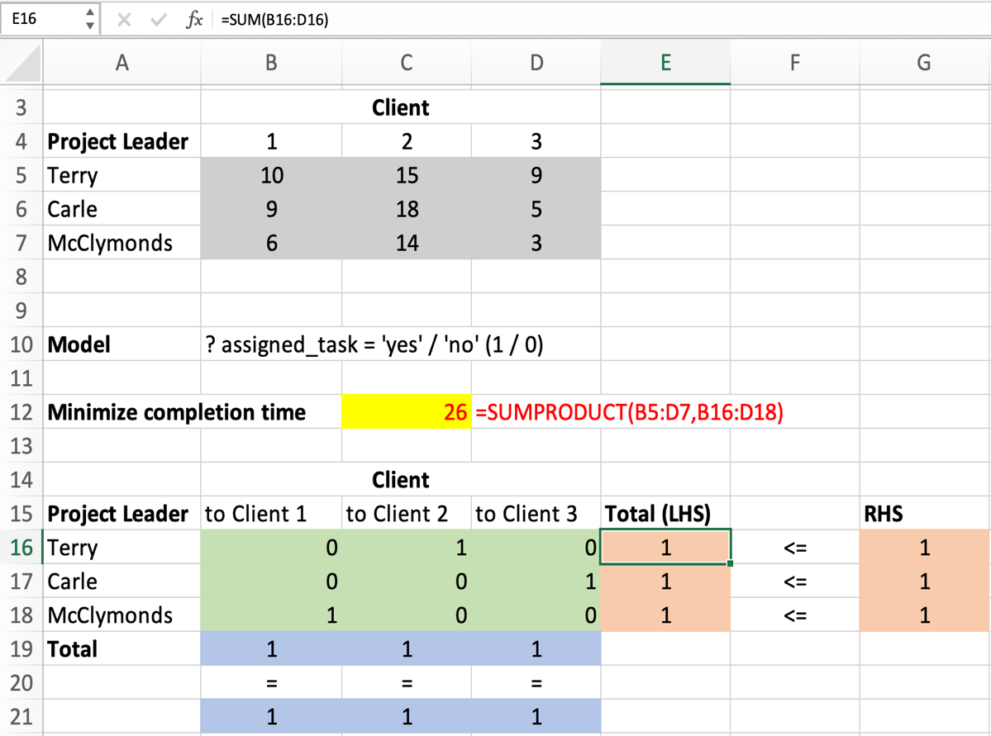

5.Optimal soln

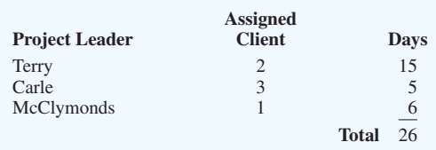

6. Practice probs

E17 a) (network model)

E 17 b) (LP formulation)

